Title of the presentation (Arial Font, size=14)
Hong Gao, Junying Zhang*
Department of Physics, Beihang University, Beijing 100191
E-mail: zjy@buaa.edu.cn (Arial Font, Size=10)

All the text and diagrams should be printed into one A4 paper. Please use Times New Roman Font (font size =12, 1 line spacing) and set the margins to 3cm from each side of paper. Reference in test should be indicated by superscript Arabic numbers.^{[1,2]} The reference format should follow the following format.
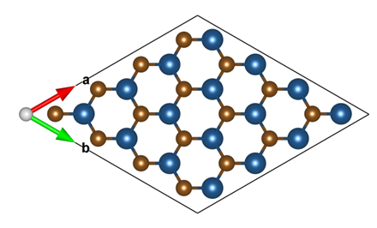
Figure 1 Optimized structure of monolayer WS₂ (Times New Roman Font. size =11)
References (Times New Roman Font, Size=12)
[1] Liang Mao, Xiaoyan Cai, Hong Gao, Xungang Diao, Junying Zhang, Nano Energy39 (2017) 172-182.
[2] Xiaoyan Cai, Liang Mao, Junying Zhang, Mingshan Zhu, Mamoru Fujitsuk, Tetsuro Majima, Journal of Materials Chemistry A 5 (2017) 10442 – 10449 (Times New Roman Font, Size=9)

